CILAB IMU SENSOR
User Guide
17th, Nov, 2017

IMU overview
The Cilab IMU was designed with multi-sensor fusion which works underwater. It includes a typical Inertial Measurement Unit (IMU), Barometer unit and thermometer. it could be incorporated into underwater systems which utilize the IMU raw data to determine current poses and navigate underwater, and use pressure and temperature sensor to determine underwater depth and water temperature. Communication is enabled via I2C to various devices.
Arduino based program is provided to read raw data from sensors and send out the IMU, pressure, temperature information through serial port.
The Cilab IMU GUI allows user to visualize the real time IMU sensor data and view the virtual IMU sensor through an Arduino board. Arduino communicate with IMU sensor via I2C and transfer real time data to PC through serial commination.
Product components
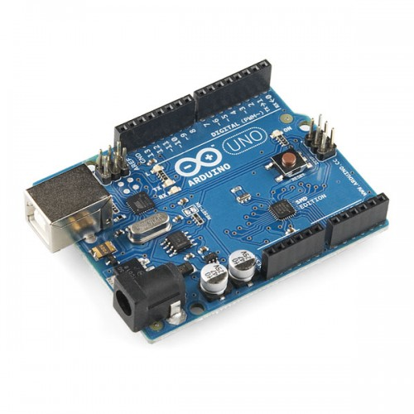
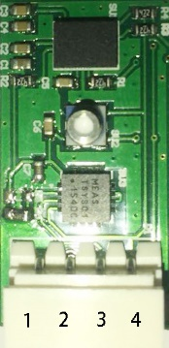
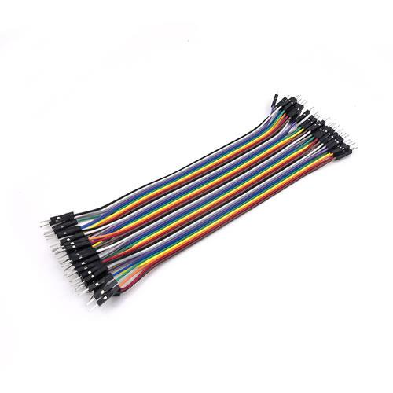
Dupont Line

IMU Board
Arduino

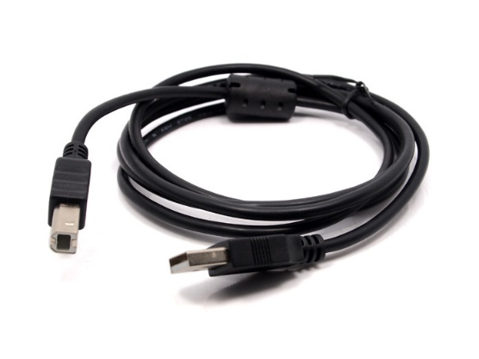
USB Cable

Connection:
- Connect the IMU board with arduino as shown below
- Connect arduino with PC with USB cable.

- Pin 1 <======> 3.3V
- Pin 2 <======> GND
- Pin 3 <======> SCL
- Pin 4 <======> SDA

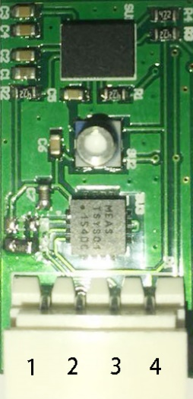
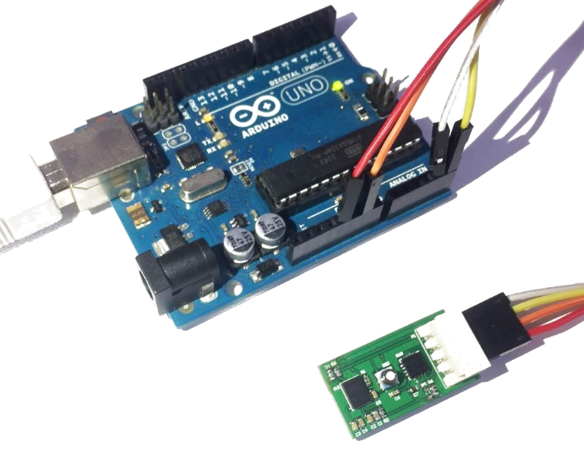

IMU Pin map
Connection

read data from sensor
Load the program with Arduino IDE, verify and upload it to Arduino board.
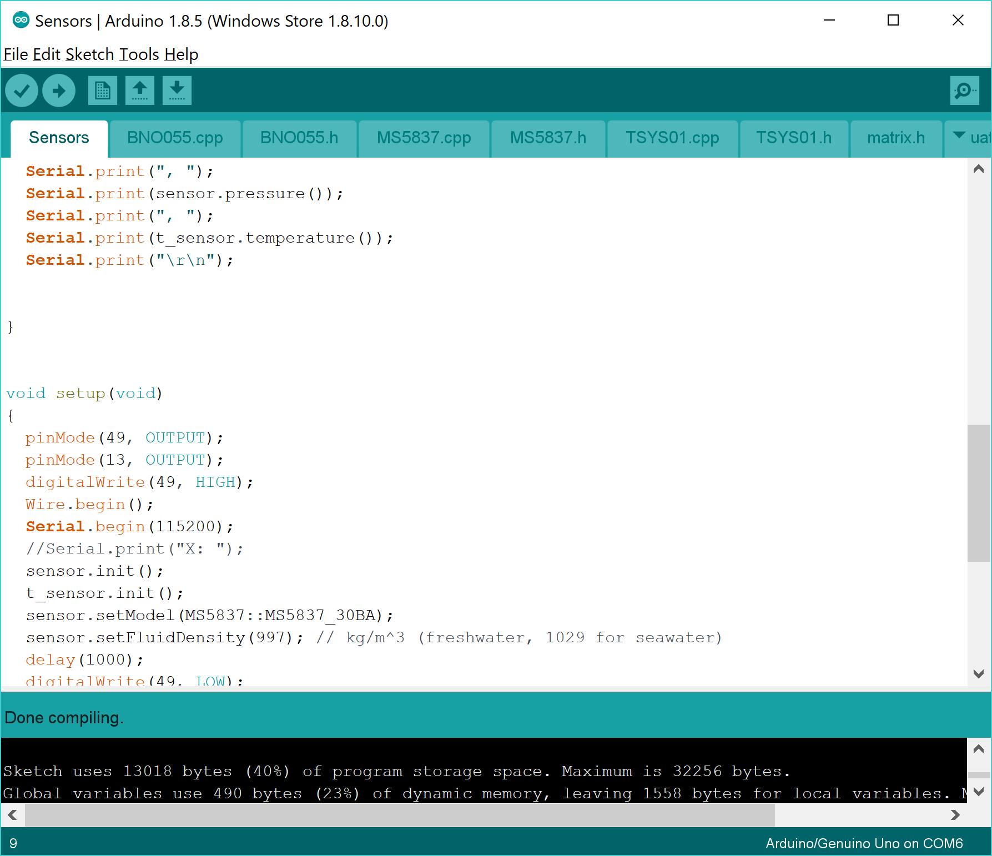
Arduino IDE

Open serial monitor, the received data will be shown in the windows.

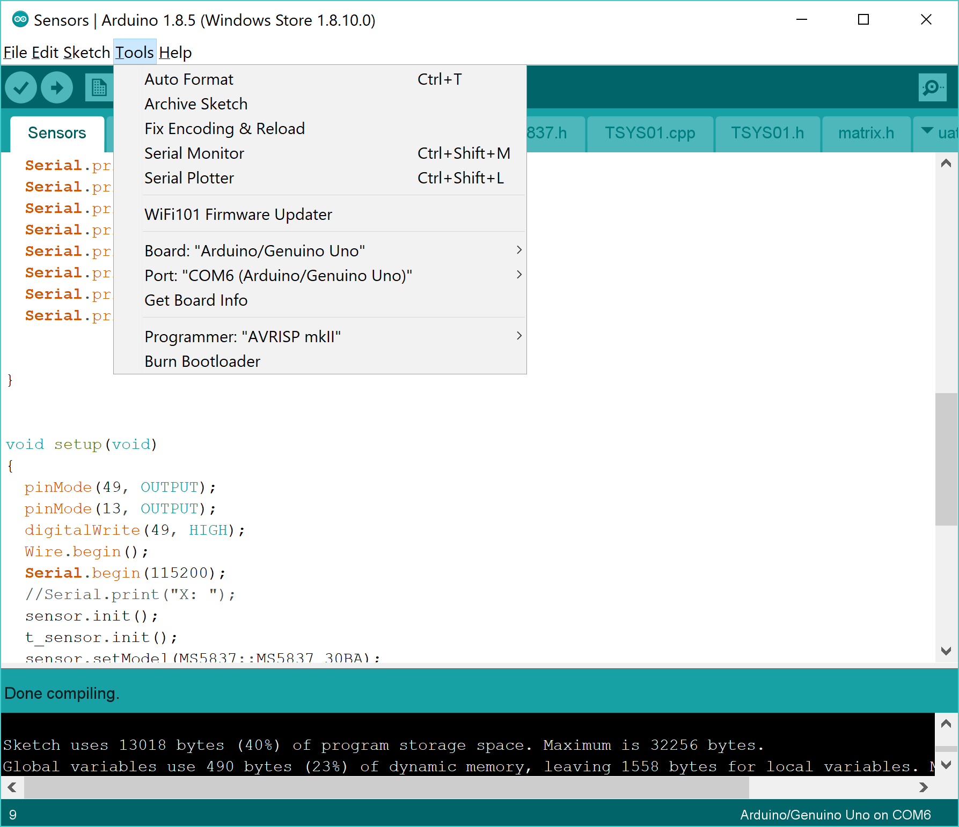
Serial Monitor

GUI Guide
- Choose com port.
- Open the port with “Open”.
- Click “show cube” to visualize orientation.

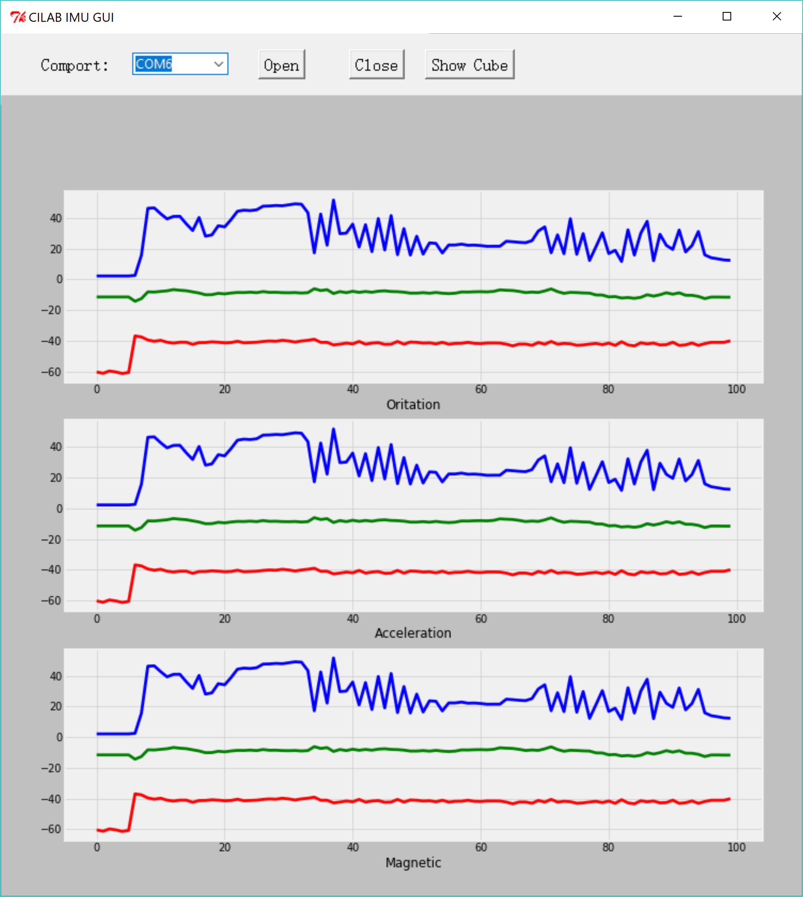
Plot data

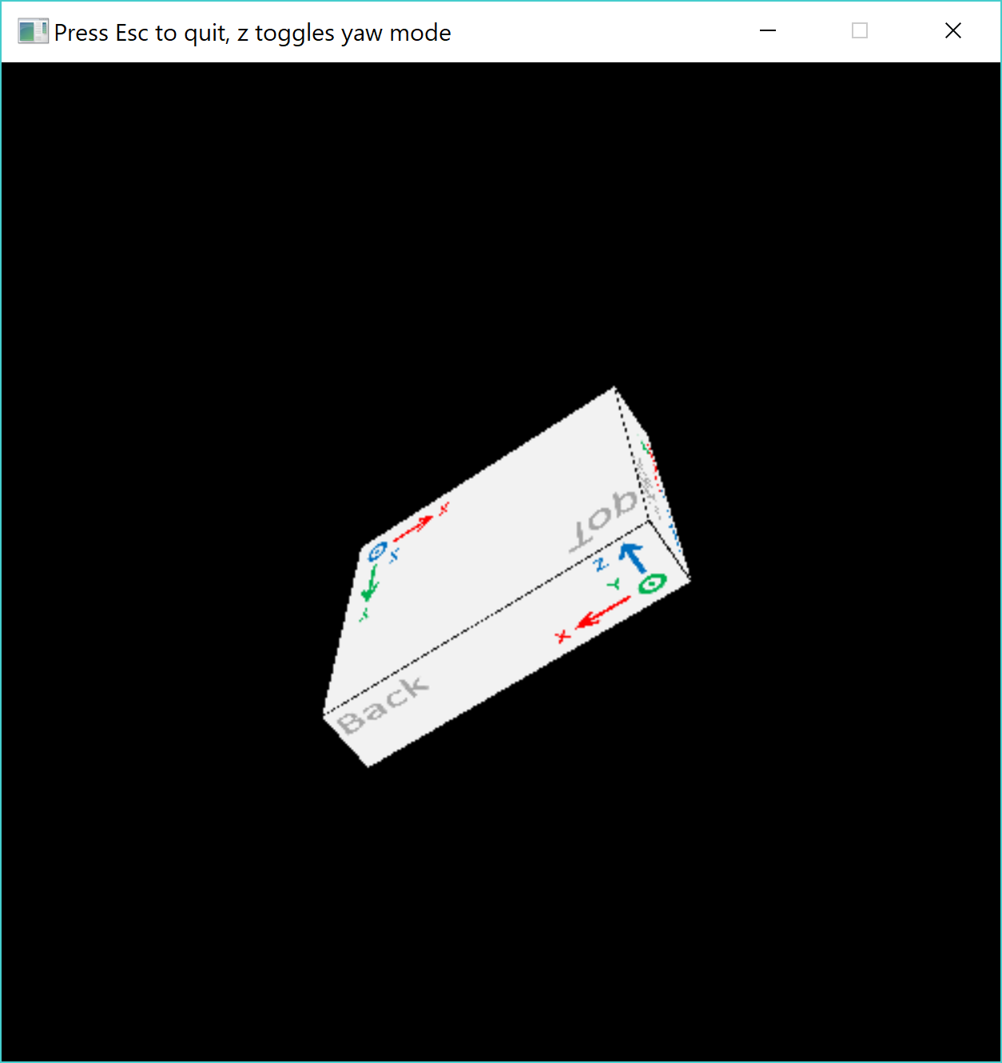
Orientation

